EXP. 2 Design Christmas dual led chaser lights

Circuit Diagram

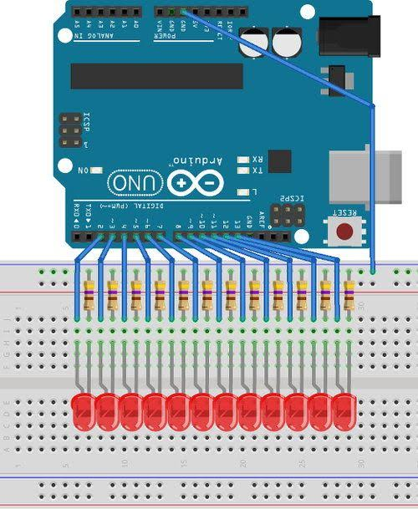

Theory

Concept Used:

-Using Arduino with breadbroad and LED to blink LED like as Christmas light decorated on Christmas tree

Learning & Observations:

-To know ,how to write program to make a loop , condition and pattern to blink the as rhythm

Problems & Troubleshooting:

-LED is not working

-Wire is not long enough to connect between Arduino and pc ,so sometime it not comfortable to use it.

-Plug in wrong circuit

Precautions:

-Not forget to plug in resistance before you use LED.

Learning Outcomes:

-I have to about kirchoff’s law and ohm’s law